Cd command

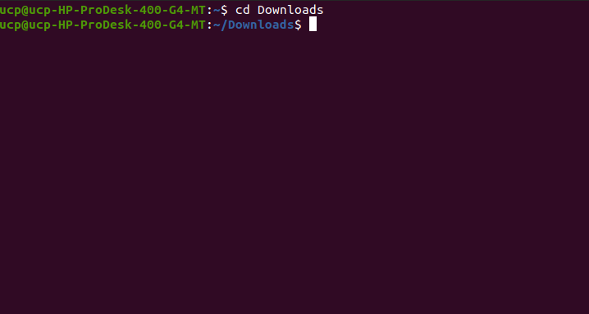man ls Command:

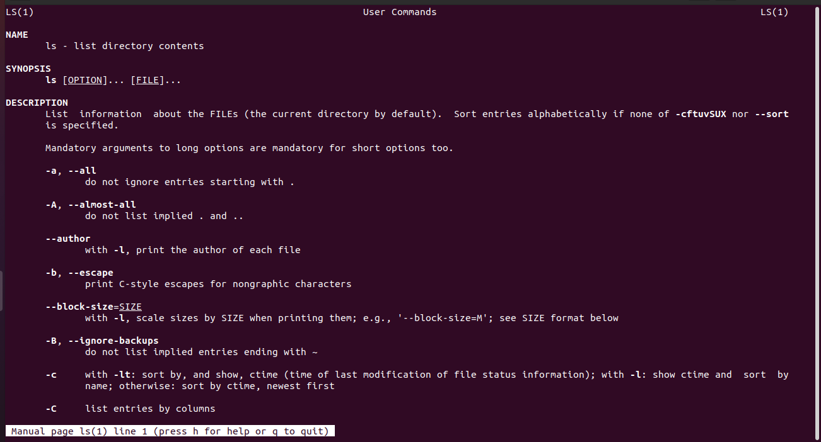

ls command:

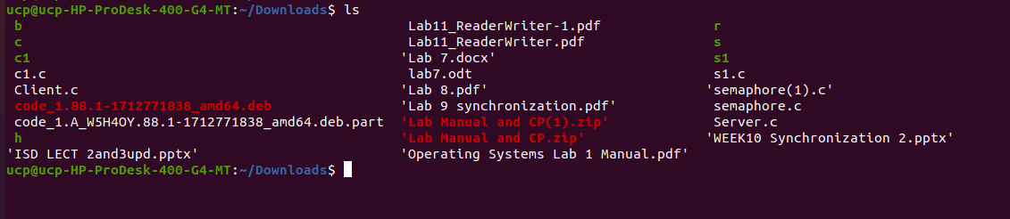

-r command:

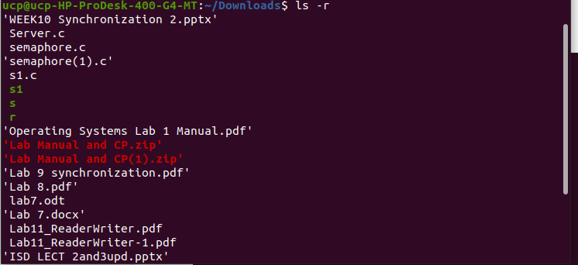ls -a command

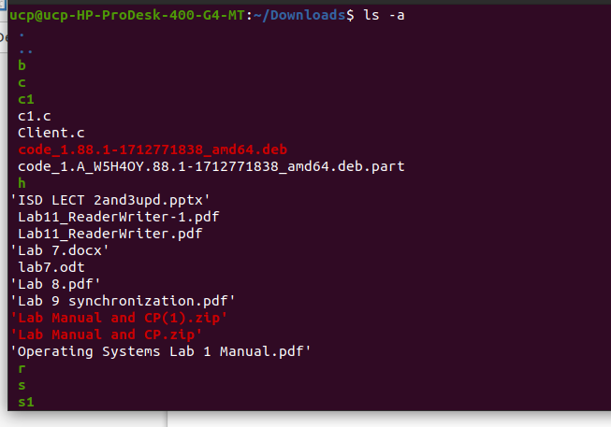

gedit OS.txt commands:

cat > ostxt command: (this can take the input through terminal ):

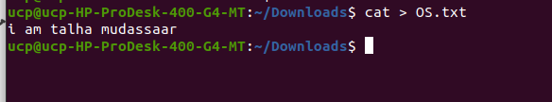-s touch os.txt and cat os.txt:

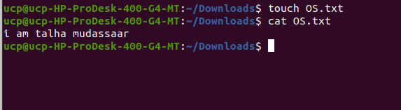

Lab task :

You have to create 2 different text files. One with your name and the second one with your

registration no. Copy and paste some dummy data from google in both file. You can even use

following link for sample data

http://www.gutenberg.org/wiki/Category:Bookshelf

after that do the following task

1) Display the data of both files

2) Display data page wise of both files

3) Combine both files in new file you have to submit

screenshots of all tasks in which results and command clearly visible.

Solution:

1. Display the data of both files

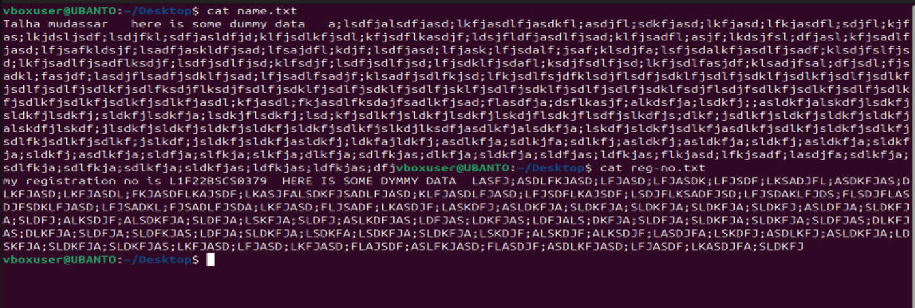

2)Display data page wise of both files

Name.txt: we use less name.txt

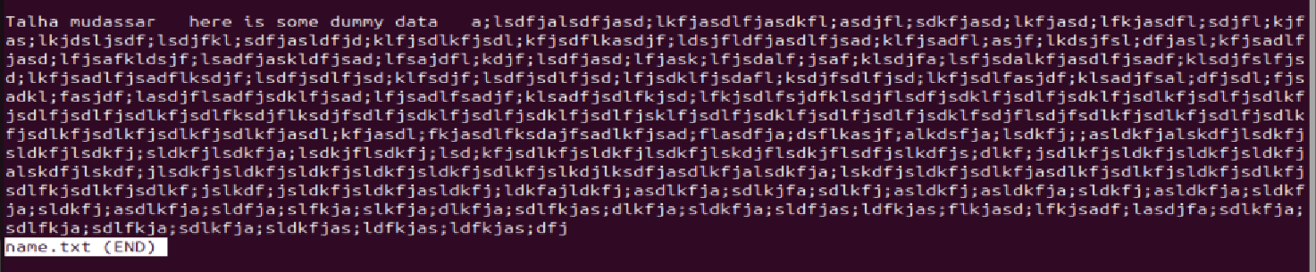

Reg-no.txt: use less reg-no.txt

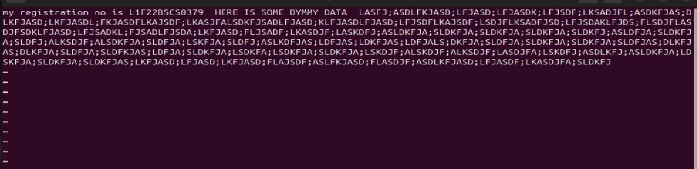

3) Combine both files in new file you have to submit

cat name.txt reg_no.txt > combined.txt

cat combined.txt

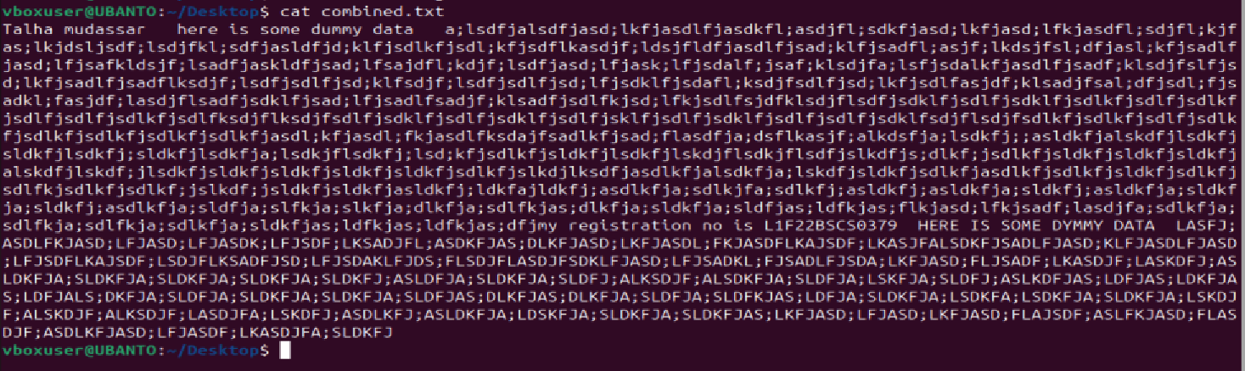

Deleting Files

rm os.txt

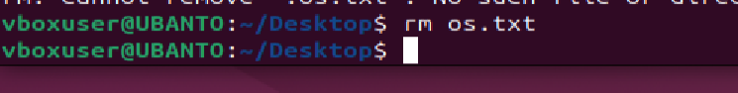

Moving & Renaming Files

mv filename newfilename will rename the file.



Copying Files

cp file1 file2 is

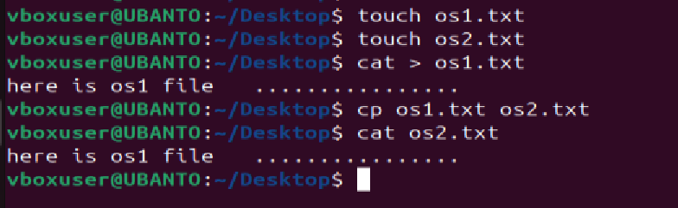

Searching contents of a file

1. Simple search using less

Using less, you can search though a text file for a keyword (pattern). For

example, to search through os.txt for the word 'science', type

less os.txt

then, still in less, type a forward slash [/] followed by the word to search

/science

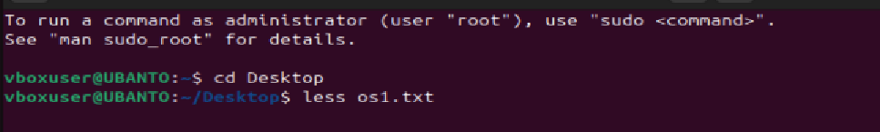



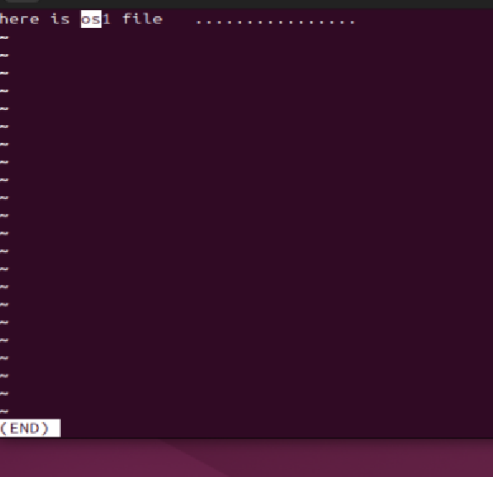

1. Grep

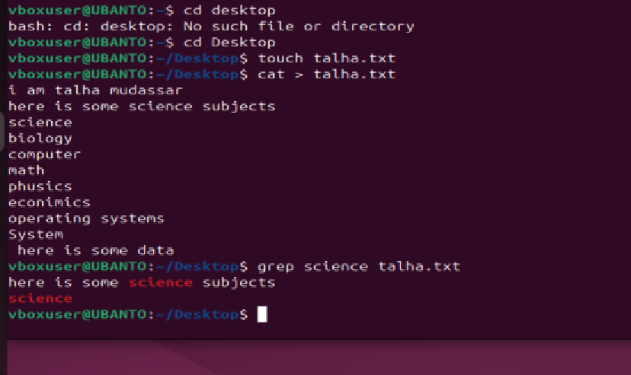

The grep command is case sensitive; it distinguishes between Science and science.

To ignore upper/lower case distinctions, use the -i option, i.e. type

grep -i science os.txt

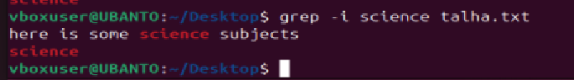

To search for a phrase or pattern, you must enclose it in single quotes (the apostrophe symbol).

For example, to search for spinning top, type

grep -i 'spinning top' os.txt



-v display those lines that do NOT match

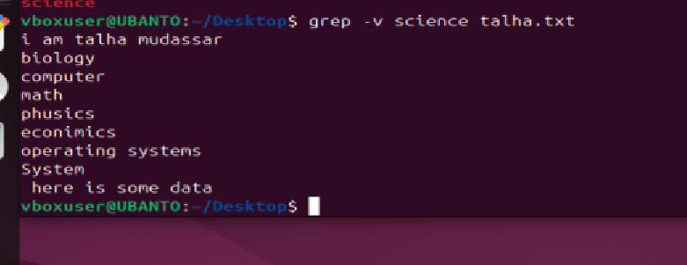

-n precede each matching line with the line number

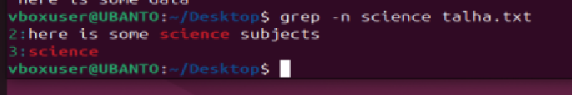

-c print only the total count of matched lines



**Combining Options: Lines Without "science" and Counting (-ivc Option)**

You can combine multiple options. For example, to count the lines that **do not** contain "science" or "Science", use:

grep -ivc science os.txt



wc (word count) of File

A handy little utility is the wc command, short for word count. To do a word count on os.txt,

type

wc -w os.txt



To find out how many lines the file has, type

wc -l os.txt

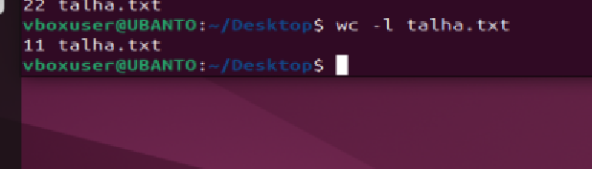

l. Appending to a file

The form >> appends standard output to a file. So, to add more items to the file list1, type

cat >> list1

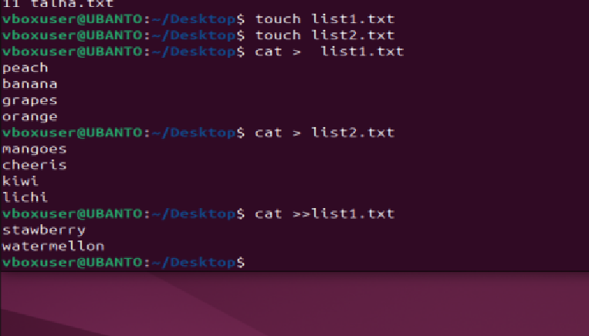

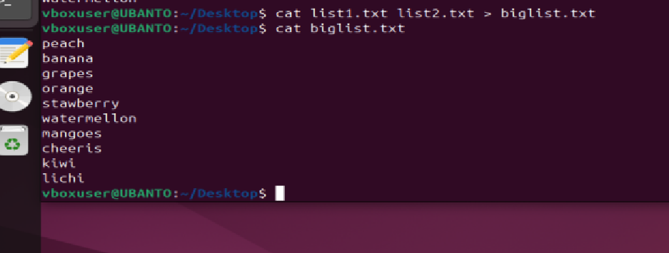

### Sorting the list:

You can sort the contents of the file alphabetically or numerically.

* To sort the content of biglist and display it on the screen:

sort < biglist

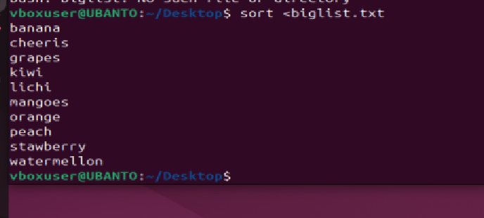

* To store the sorted output in a new file called slist:

sort < biglist > slist

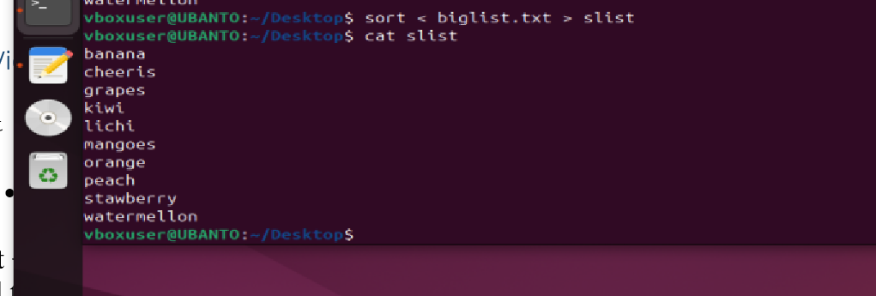

### 1. Viewing directory details using ls -l:

ls -l

* This will list the files and directories in the current directory with detailed information like file permissions, owner, group, size, and modification time.

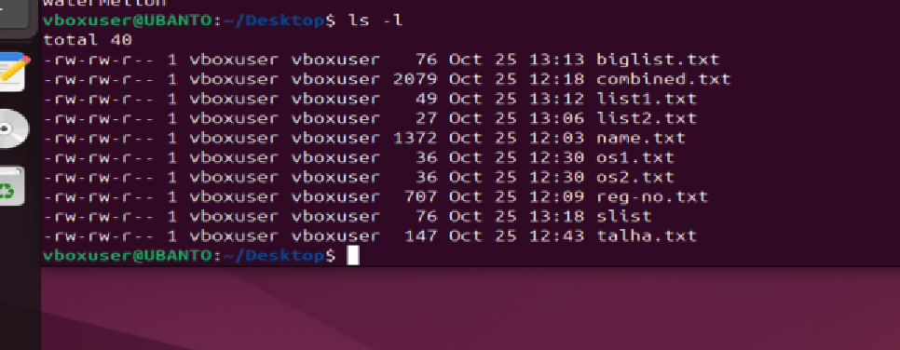

### 2. Changing access rights using chmod:

#### a) Remove read, write, and execute permissions for group and others on os.txt:

chmod go-rwx os.txt

* This command removes **read**, **write**, and **execute** permissions for both **group** and **others** for the file os.txt.



#### b) Give ****read**** and ****write**** permissions to everyone (user, group, and others) on os.txt:

chmod a+rw os.txt

* This command adds **read** and **write** permissions to everyone for the file os.txt.

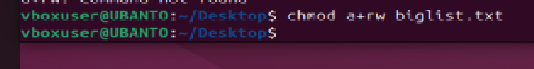

### 3. Verifying the changes:

* You can check if the permissions have changed by running:

ls -l os.txt



* This will show the updated permission string for the file os.txt.

LAB TASK2:

• **Change Permissions:** Use the chmod command to change the permissions. For example, to give read, write, and execute permissions to the owner, and read permissions to the group and others:

chmod 744 os.txt

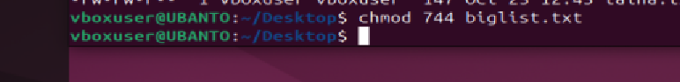

This command sets the permissions to:

* Owner: read (4), write (2), execute (1) = 7
* Group: read (4) = 4
* Others: read (4) = 4

• **Check Permissions:** Use the ls -l command to list the details of the file, including permissions:

ls -l os.txt

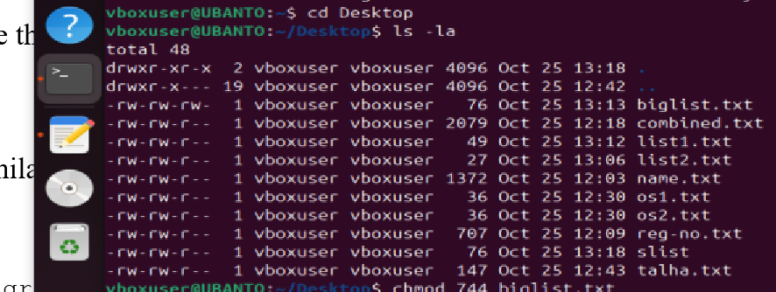

### Directory Manipulation Steps

1. **Open Terminal:**  
   Press Ctrl + Alt + T to open the terminal.
2. **Create a Directory:** To create a new directory named OS, use the mkdir command:

mkdir OS



1. **Change into the New Directory:** Use the cd command to change your current directory to OS:

cd OS



1. **Create Another Directory:** If you want to create a subdirectory within OS, use:

mkdir sub_directory_name

Replace sub_directory_name with your desired name.



1. **Create a Directory in a Different Location:** To create a directory named MUSIC under the /tmp directory, run:

mkdir /tmp/MUSIC



1. **Check Current Directory:** To check which directory you are currently in, use:

Pwd



1. **Stay in the Current Directory:** To remain in the current directory, type:

cd .



1. **Go to Parent Directory:** To go back to the parent directory, use:

cd ..



1. **List the Contents of a Directory:** You can list the contents of your home directory using:

ls ~



To list the contents of the OS directory (from anywhere in the file system):

ls ~/OS

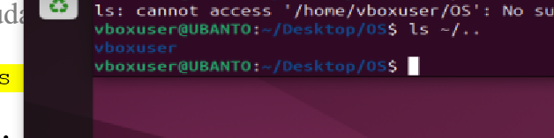

1. **List Parent Directory:** To list the contents of the parent directory, use:

ls ~/..



1. **Remove a Directory:** To remove the OS directory (make sure it’s empty first):

rmdir OS

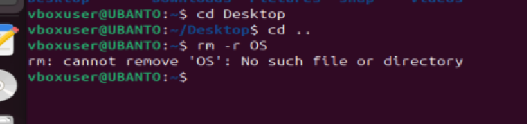

1. **Check Command History:** To see the history of commands you have used so far, type:

* **Wildcards:** To see files that start with "list":

ls list*

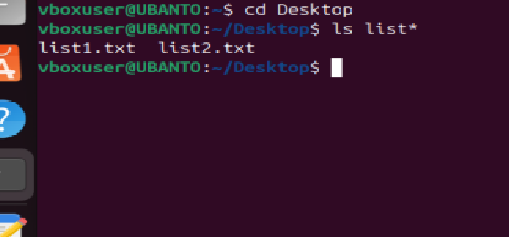

To see files that end with "list":

ls *list

